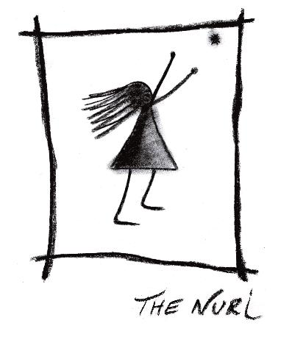

The Nuri – Life on jupiter (Music Box 2011)

A single word from this mouth world turns blurry
A simple idea can change the world makes it clear again
The feeling is strange become aware of our littleness
Everything turns out to be rude no place for you with your tenderness

In my mind anything is possible
In my dreams I live on Jupiter
No one's omniscient anyway

There was a man living for symphonies
One substance found is able to save a million lives
His faith in God made him doubt anything
Everything turns out to be rude no place for you with your tenderness

In my mind anything is possible
In my dreams I live on Jupiter
No one's omniscient anyway

